Johnson Video Store Metadata and SQL Code

Kelsey Thompson

Colorado State University Global

MIS407: Database Concepts

Dr. Mario Missakian

May 20, 2024

**Johnson Video Store Metadata and SQL Code**

In this milestone, regarding the Johnson Video Store, I will provide my schema/data dictionary, SQL code for creating the tables and the seeding of the database.

View my metadata in the attached Excel, my full SQL code in the attachment and the below screenshots representing successful execution of my code for table creation and database seeding in PostgreSQL. I have provided 20 rows of data for each table

1. View this screenshot of my SQL code showing successful execution of my code:

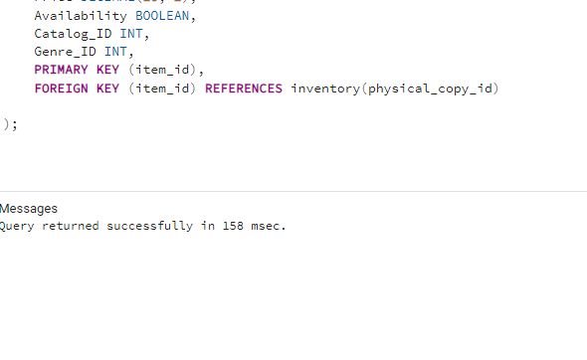

1. Below, I was seeding the database. This was executed successfully

